Bill/KOT Preferred Configuration

Path : Operation >> Bill / KOT Print >>Bill/KOT Preferred Configuration.

Steps to reach Bill/KOT Preferred Configuration:
Step 1 : Operation in Steps to reach Bill/KOT Preferred Configuration : Open your Operation module from the Billing Application (POS).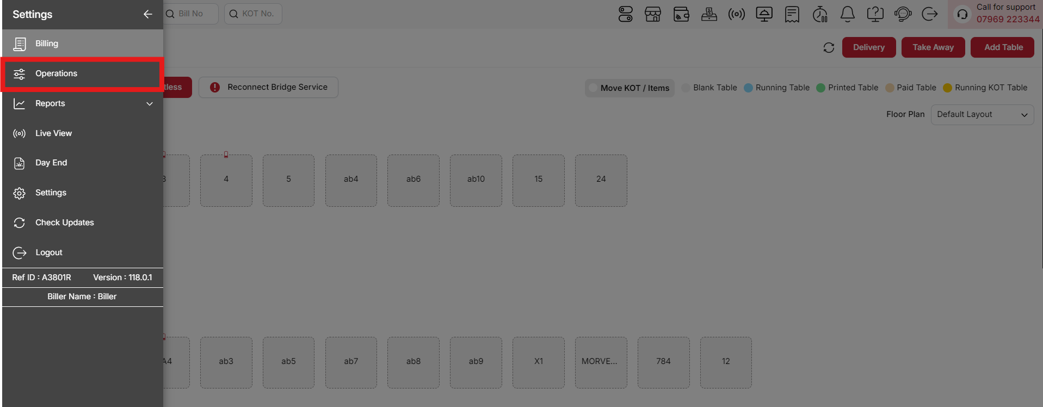
{Image Name: Operations,
Description: The red box highlights the Operations menu in the sidebar, offering tools like Reconnect Bridge Service and order management options. Users can handle tasks such as fixing connectivity and managing tables like Blank Table and Running Table. Here is an image of Step 1 Operations in Steps to Reach Bill/KOT Preferred Configuration.}
Step 2 : Bill / KOT Print in Steps to reach Bill/KOT Preferred Configuration : Click on Bill / KOT Print.
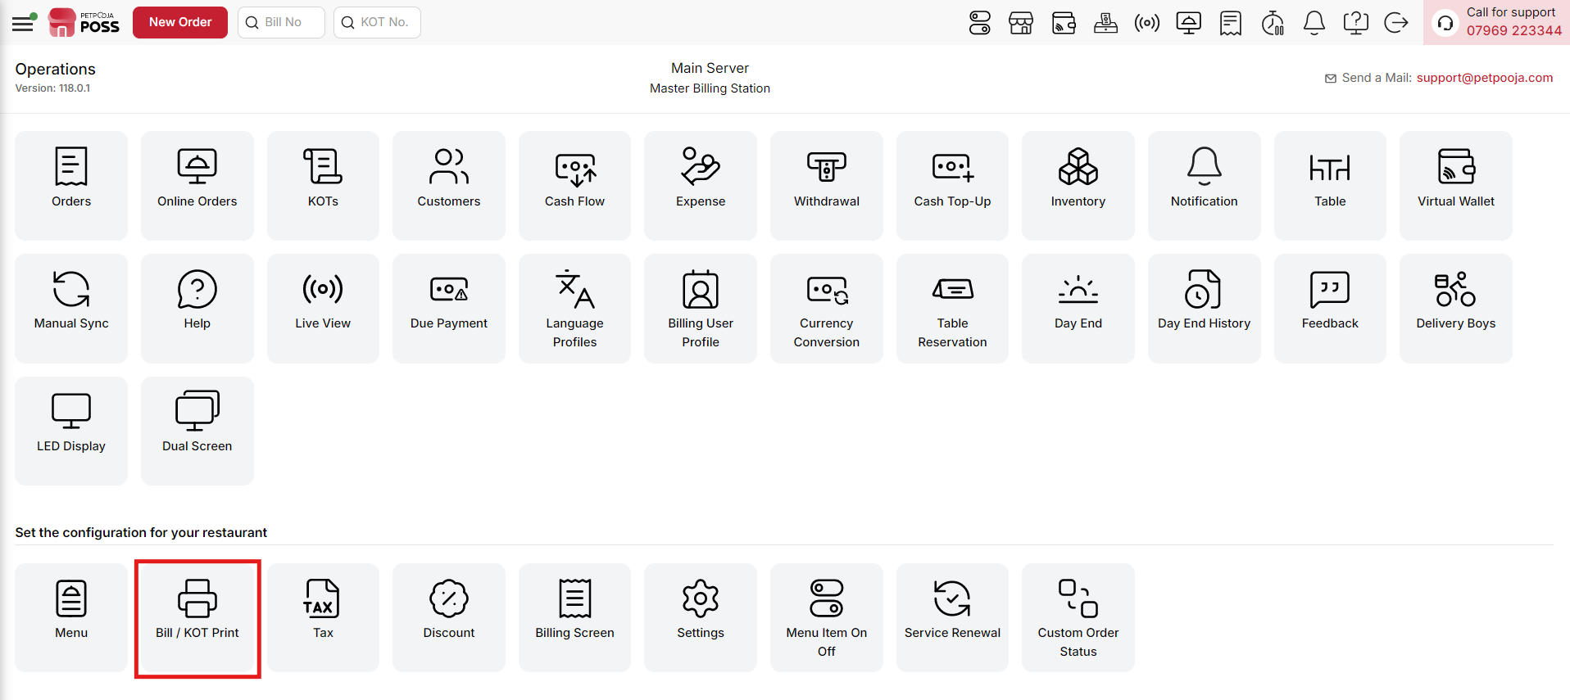
{Image Name: Bill / KOT Print,
Description: The red box highlights the Bill / KOT Print option, which allows users to configure and manage bill and kitchen order ticket printing settings. This feature ensures accurate and efficient printing of bills and KOTs based on the restaurant’s operational requirements.Here is an image of Step 2 Bill / KOT Print in Steps to Reach Bill/KOT Preferred Configuration.}
Step 3 : Bill/KOT Preferred Configuration in Steps to reach Bill/KOT Preferred Configuration : Select Bill/KOT Preferred Configuration to set preferences for printing bills and KOTs, such as layout, format, and printer selection.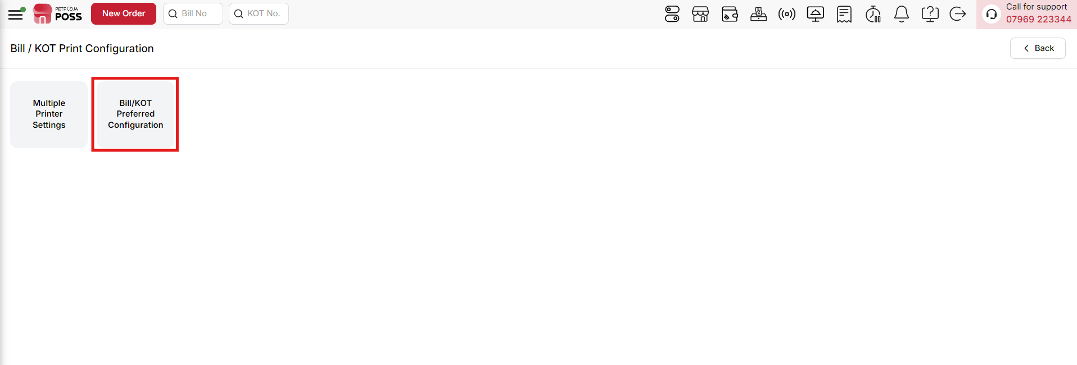
{Image Name: Bill/KOT Preferred Configuration,
Description: The red box highlights the Bill/KOT Preferred Configuration option, which allows users to set default printing preferences for bills and kitchen order tickets. This feature ensures that the selected printer and format are consistently applied during the billing process for smoother operations.Here is an image of Step 3 Bill/KOT Preferred Configuration in Steps to Reach Bill/KOT Preferred Configuration.}

Key Features Of Bill/KOT Preferred Configuration :
(Bill/KOT Preferred Configuration) Note: If you are not able to see or use the Bill/KOT Preferred Configuration option in your billing application, it means that you do not have the required permission. To enable this, you need to go to the Owner Dashboard and open the User Management section. Inside User Management, you will find a permission called Point of Sale Configuration Details, which has two options: Read and Write. If you want to edit the configuration, you must enable both Read and Write. If you are not able to see the Save Button, then you must ensure that the Write permission is enabled. After allowing the permission, perform a manual sync so the system updates the rights properly. Once the sync is done, log out from the billing application and then log in again. After this process, the Bill/KOT Preferred Configuration option will become visible and you can use it without any problem.

Configuration Options Available in Bill/KOT Preferred Configuration
Each option allows customization of how KOTs and Bills are printed. Here are the details:
(Bill/KOT Preferred Configuration) Print KOT on Print Bill (First Time Only):
- Check: The KOT will be printed only the first time the bill is printed. After that, the KOT and the bill will be printed together for subsequent prints.
- Uncheck: The KOT will not follow this rule and will be printed according to the standard printing settings, without restricting to the first-time print.
(Bill/KOT Preferred Configuration) Consider Non-Prepared KOT in Bill
- Check: Items that are not yet prepared (non-prepared KOT) will still be included in the bill. This ensures that all ordered items, even if not ready, are billed.
- Uncheck: Only prepared items will be included in the bill. Non-prepared items will not be billed until they are ready.
(Bill/KOT Preferred Configuration) Print Only Modified KOT
- Check: Only the items that have been modified or updated in a KOT will be printed. This prevents reprinting unchanged items and saves paper.
- Uncheck: All items in the KOT will be printed, including those that have not been modified.
(Bill/KOT Preferred Configuration) Print Only Modified Items in KOT
- Check: Only items that have been changed, added, or updated in a KOT will be printed. This helps reduce unnecessary printing and keeps the kitchen workflow efficient.
- Uncheck: All items in the KOT will be printed, regardless of whether they were modified or not.
(Bill/KOT Preferred Configuration) Print Deleted Items in KOT
- Check: Any items that were removed or deleted from a KOT will be printed separately. This helps keep track of deleted items for the kitchen and billing records.
- Uncheck: Deleted items will not be printed, and only the current items in the KOT will appear.
(Bill/KOT Preferred Configuration) Print Deleted Items in Separate KOT
- Check: Any items that are deleted or removed from an existing KOT will be printed in a separate KOT, keeping them distinct from the main KOT for better tracking.
- Uncheck: Deleted items will not be printed separately and will remain part of the main KOT if printed again.
(Bill/KOT Preferred Configuration) Print Cancelled KOT
- Check: Any KOT that is cancelled will be printed separately. This helps track cancelled orders for the kitchen and billing records.
- Uncheck: Cancelled KOTs will not be printed separately and will not appear in the print records.
(Bill/KOT Preferred Configuration) Print KOT No. on Bill as (Token No.)
- Check: The KOT number will be printed on the bill as a Token Number, making it easier for the kitchen and staff to identify orders quickly without confusion between KOT and bill numbers.
- Uncheck: The KOT number will not be printed as a Token Number on the bill.
(Bill/KOT Preferred Configuration) Print CWT (Category-wise Taxes) Bifurcation on Bill
- Check: The bill will display Category-wise Tax (CWT) details, showing tax breakdown for each category separately. This helps in clear understanding of taxes for different types of items.
- Uncheck: The bill will show only the total tax amount without breaking it down by category.
(Bill/KOT Preferred Configuration) Individual Item price will be shown (without backward tax) on printed bill
- Check: Each item’s price will be shown without backward tax on the printed bill. Tax will be displayed separately.
- Uncheck: Each item’s price will include backward tax on the printed bill.
(Bill/KOT Preferred Configuration) Individual Item price will be shown (including backward tax) on printed bill
- Check: Each item’s price on the printed bill will include backward tax, showing the total price per item with tax included.
- Uncheck: Each item’s price will be shown without backward tax, and tax will be displayed separately.
(Bill/KOT Preferred Configuration) Show Backward tax on printed bill
- Check: The printed bill will display backward tax separately, showing the tax applied on the item price clearly.
- Uncheck: The printed bill will not show backward tax separately.
(Bill/KOT Preferred Configuration) Show Duplicate On a Bill If its Printed Multiple Time
- Check: If a bill is printed more than once, the word “Duplicate” will appear on the bill to indicate it is not the original.
- Uncheck: Bills printed multiple times will not show the word “Duplicate,” and all prints will look the same as the original.
(Bill/KOT Preferred Configuration) Show Duplicate on a KOT if It’s Printed Multiple Times
- Check: If a KOT is printed more than once, the word “Duplicate” will appear on the KOT to indicate it is not the original.
- Uncheck: KOTs printed multiple times will not show the word “Duplicate,” and all prints will look the same as the original.
(Bill/KOT Preferred Configuration) Show "Customer Paid" and "Return to Customer" On Bill
- Check: The printed bill will display the amount paid by the customer and any amount returned to them. This helps in clear communication of payment details.
- Uncheck: The bill will not show the customer paid or returned amounts.
(Bill/KOT Preferred Configuration) Show special notes/addons below item row in kot. (only for general printer)
- Check: Any special notes or addons for an item will be displayed below the item row in the KOT. This is visible only on general printers and helps the kitchen staff see item instructions clearly.
- Uncheck: Special notes or addons will not be displayed below the item row in the KOT.
(Bill/KOT Preferred Configuration) Show addons in bill print.
- Check: Any addons added to an item will be displayed on the printed bill, making it clear to the customer what extras were included.
- Uncheck: Addons will not be shown on the printed bill, and only the main item will appear.
Everyday reset KOT no from : This option lets you set the number from which your KOTs will start each day.When a new day starts, the KOT number will start again from this number.It helps to keep daily orders organized and easy to track.
(Bill/KOT Preferred Configuration) Show Order Barcode on Both Bill and KOT Print
- Check: The order barcode will be printed on both the bill and the KOT. This helps in faster order scanning and tracking in the kitchen and billing.
- Uncheck: The order barcode will not be printed on the bill or KOT.
- Note: You can scan the barcode to mark an order as ready.This setting can be set for each printer in printer settings.Riders from Swiggy and Zomato can also use the same barcode to pick up the order.
(Show Order Barcode on Both Bill and KOT Print) Print Barcode of :
- (Print Barcode of) Full Order ID – Prints the complete order ID as barcode.
- (Print Barcode of) Last 4 Digits – Prints only the last 4 digits of the order ID as barcode.
- (Last 4 Digits) Note: You can scan the barcode to mark an order as ready.This setting can be set for each printer in printer settings.This option Will Not Work in Petpooja Scanner App.

(Bill/KOT Preferred Configuration) Show order barcode on KoT print
- Check: The order barcode will be printed only on the KOT. This helps the kitchen staff scan and track orders faster.
- Uncheck: The order barcode will not be printed on the KOT.
(Show order barcode on KoT print) Note:You can scan the barcode to mark an order as ready.This setting can be managed separately for each printer in printer settings.Riders from Swiggy and Zomato can also use the same barcode to pick up the order.
(Show order barcode on KoT print) Print Barcode of:
- (Print Barcode of) Full Order ID – Prints the complete order ID as barcode.
- (Print Barcode of) Last 4 Digits – Prints only the last 4 digits of the order ID as barcode.
(Last 4 Digits)Note:You can scan the barcode to mark an order as ready.This setting can be managed for each printer.This option will not work in the Petpooja Scanner App.

(Bill/KOT Preferred Configuration) Show Order Barcode on Bill Print
- Check: The order barcode will be printed only on the bill. This helps in faster order scanning and tracking at the billing counter.
- Uncheck: The order barcode will not be printed on the bill.
(Show Order Barcode on Bill Print) Note:You can scan the barcode to mark an order as ready.This setting can be managed separately for each printer in printer settings.Riders from Swiggy and Zomato can also use the same barcode to pick up the order.
Print Barcode of:
- Full Order ID – Prints the complete order ID as barcode.
- Last 4 Digits – Prints only the last 4 digits of the order ID as barcode.
(Last 4 Digits) Note:You can scan the barcode to mark an order as ready.This setting can be managed separately for each printer.Riders from Swiggy and Zomato can also use the same barcode to pick up the order.This option will not work in the Petpooja Scanner App.
(Bill/KOT Preferred Configuration) Assign Bill Sales to KOT Punched User
- Check: The sales from the bill will be assigned to the user who punched the KOT, helping track sales per employee accurately.
- Uncheck: Bill sales will not be assigned based on the KOT punched user; sales will follow the default assignment method.
(Bill/KOT Preferred Configuration) Print While Moving One Table to Another Table (Table / KOTs / Items)
- Check: When a table, KOT, or items are moved to another table, a printout will be generated automatically. This helps the kitchen and billing staff stay updated about table changes.
- Uncheck: No printout will be generated when a table, KOT, or items are moved, and the staff must track changes manually.
(Bill/KOT Preferred Configuration) Print KOT from Captain App
- Check: Allows the KOT to be printed directly from the Captain App, enabling staff to generate KOTs from mobile devices without using the POS.
- Uncheck: KOTs cannot be printed from the Captain App and must be printed only from the POS system.
(Bill/KOT Preferred Configuration) Display Errors While Checking Printer Status
- Check: If there is any issue with the printer, an error message will be displayed while checking the printer status. This helps quickly identify and fix printer problems.
- Uncheck: Printer errors will not be displayed, and issues may go unnoticed until printing fails.
(Bill/KOT Preferred Configuration) Save Button : Clicking "Save" will apply the selected settings..
(Bill/KOT Preferred Configuration)Cancel Button : Clicking "Cancel" will discard any changes made.Settings will remain as they were before modifications.

